Create 2 EC2 instances on 2 different regions and install nginx using terraform script.

main.tf

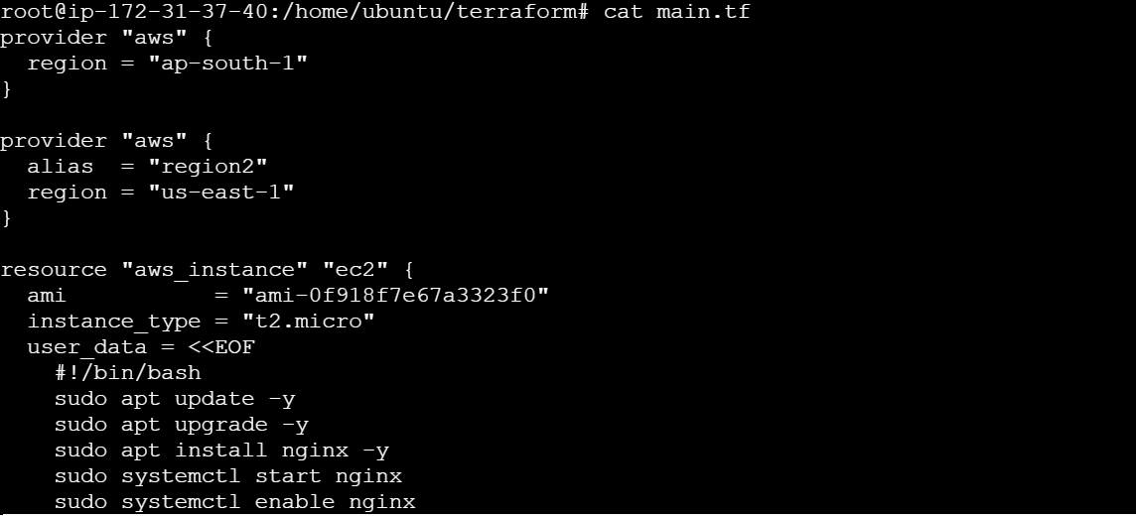

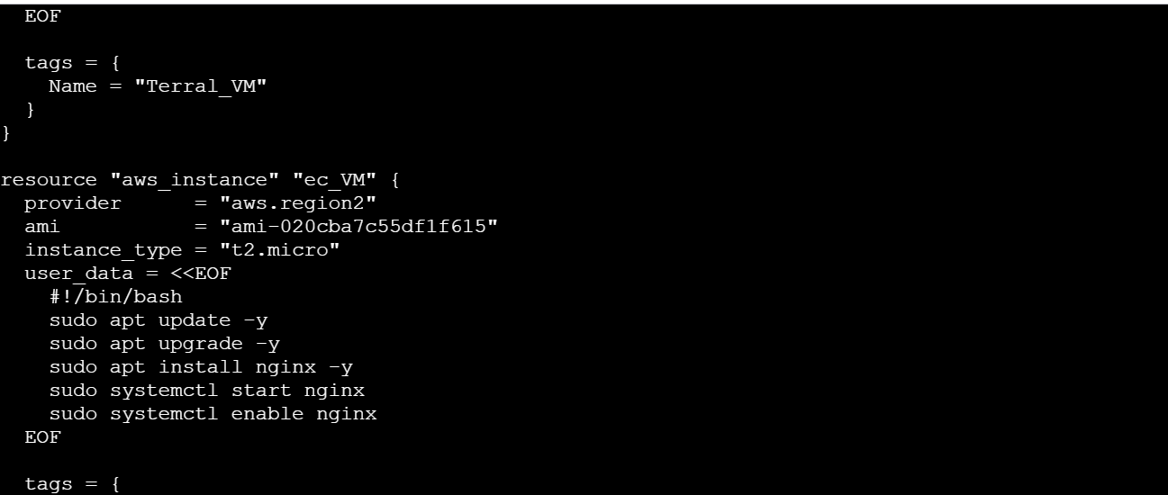

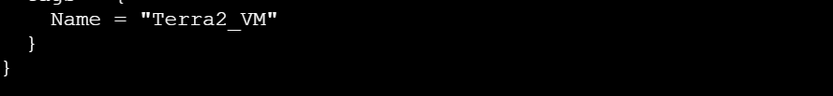

terraform init

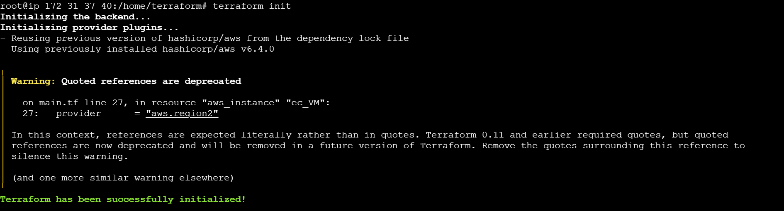

terraform plan

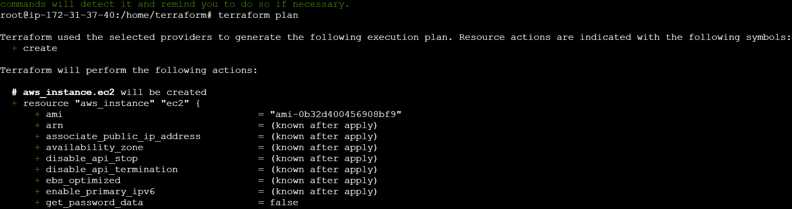

terraform apply

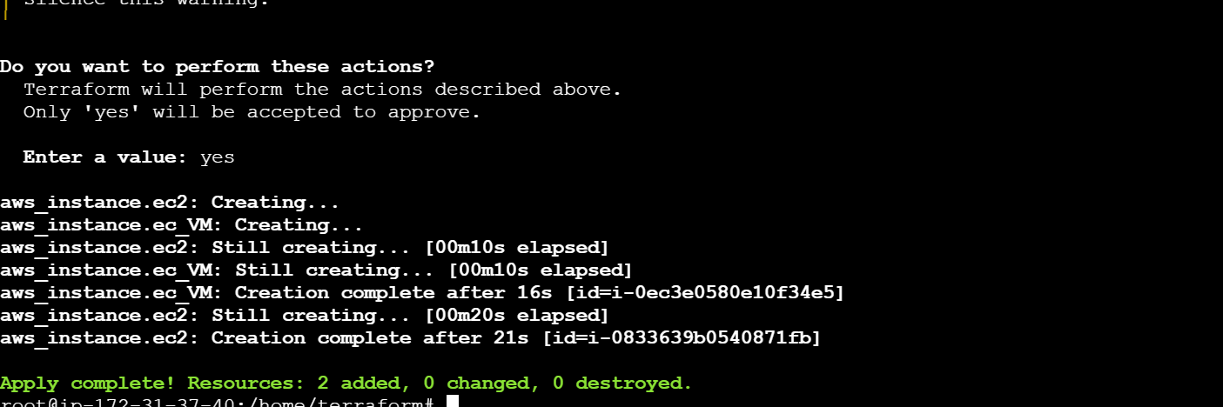

ap-south -1 (Terra1_VM)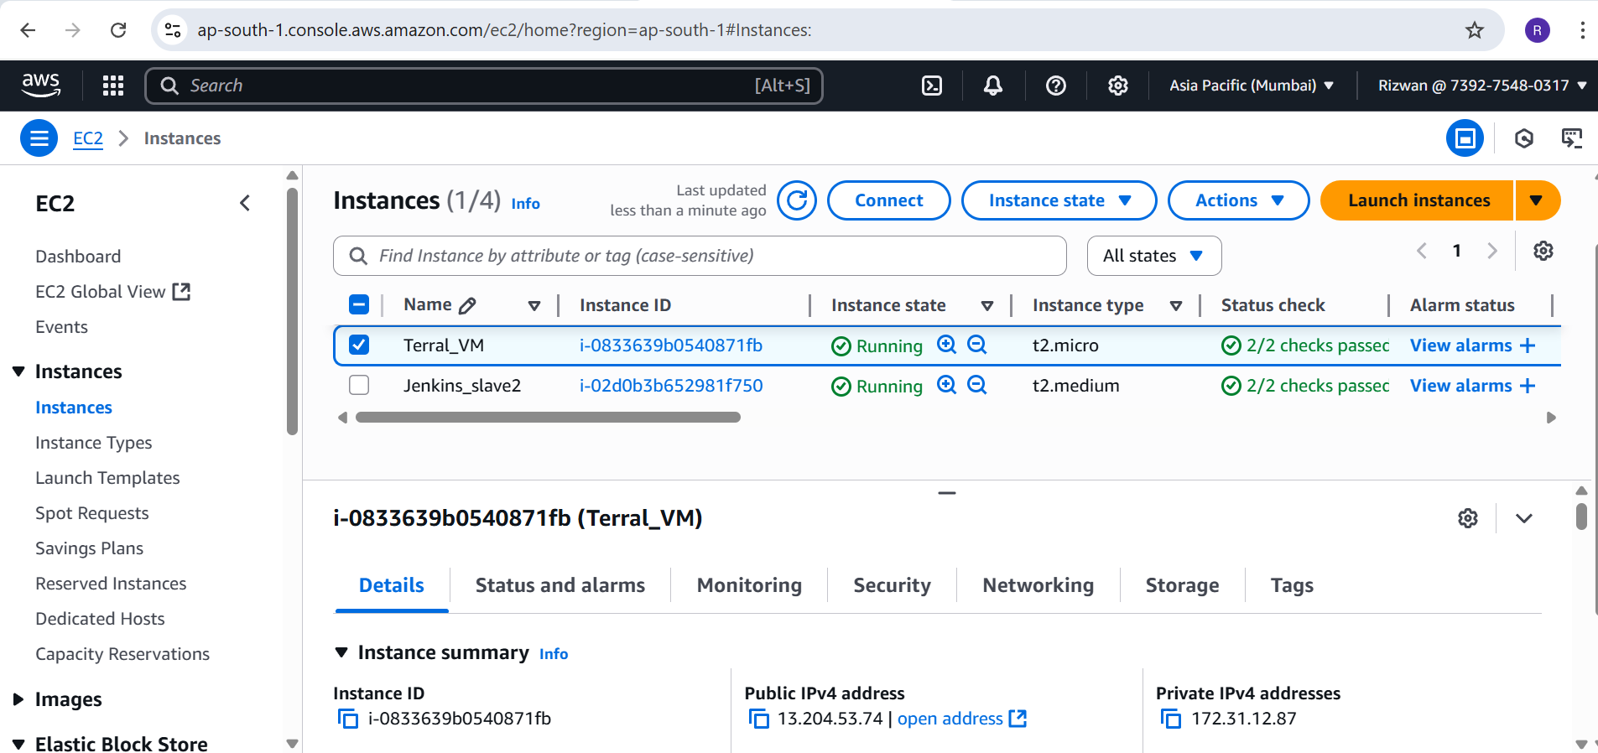

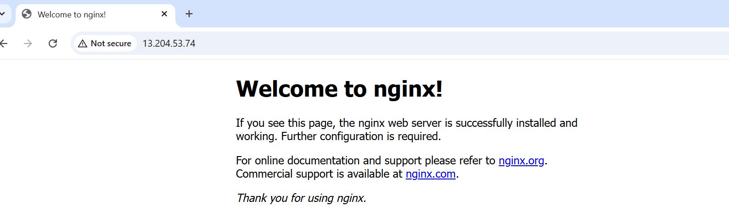

us-east-1 (Terra2_VM)

